Infoconnect Monitoring Utilizing Site 24X7

**Requirements Document**

*May 2016*

# Scope

The scope of this project is to provide users with a visualization of the end to end Infoconnect solution. This visualization will display each of Infoconnect’s modules and their specific monitors. Users will be able to see the current status of each monitor and specific statistics regarding up or down time. This page will also notify users when a monitor is not working as expected or down. This page will be used for internal analysis purposes.

There will be an Infoconnect Module Monitoring Dashboard available for Infoconnect clients. Clients will use this page for multiple purposes; being notified if Infoconnect is up or down, specific statistics of their service (number of calls made, etc.) and of any scheduled maintenance.

The internal launch page will provide a link to an analytical view of each of Infoconnect’s modules. The dashboard will consist of two charts that break down the module and monitors; a bar graph that shows the number of monitors by module and a circle graph that shows the number of monitors by status. The user will be able to drill through these graphs to see a numeric representation of the status of the module and each monitor.

Summary reports will be available for each module. There will be a weekly reports sent to the Infoconnect team that gives an overview of each module and specific monitors regarding down time and response time. Users will also have the ability to use an interface within Site 24X7 to select a specific date range or a specific Infoconnect module to view a detailed summary report. Users will select a start date and an end date or specific monitor to generate a report. These reports will be utilized for internal analysis purposes.

There are associated team members that are assigned to each of Infoconnect’s modules. Notifications of outages will be sent to those assigned team members in the form of an email. An email distribution list assigned to each module will be used to contact each member when there is an outage of their assigned module. When there is an outage, team members of that module are responsible for executing their escalation plan to resolve the issue in a timely manner. It is also their responsibility to contact Infoconnect’s on-call developer and notify them of the outage. In addition, team members will be provided with login credentials to Site 24X7 to view statistics and the current status of their module.

Clients will be provided with log in credentials to view the current status of Infoconnect and other specific details that are relevant to that client. This page will include the current status of Infoconnect (is Infoconnect up or down), how many calls that client made, what type of calls were made by that client, and how many matches did Infoconnect supply back to the client. Infoconnect will also use this to notify clients when there is a scheduled maintenance down time.

# Infoconnect Monitoring Dashboard: Internal

**Module and Monitor Dashboard**

The Infoconnect Module Dashboard will cover all of Infoconnect’s modules and their associated monitors. The modules will be displayed by a visual tree graph that is in hierarchically ordered representing Infoconnect’s end to end solution.

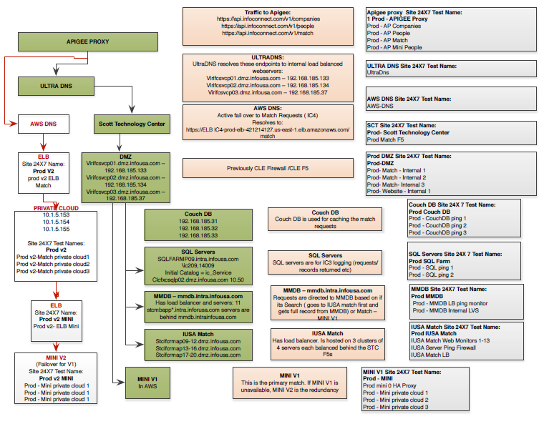

Below are Infoconnect’s module group names and their individual monitors:

* Apigee
  + Prod - AP Companies
  + Prod - AP People
  + Prod - AP Match
  + Prod - AP Mini People
* ULTRA DNS
  + UltraDns
* AWS DNS
  + AWS-DNS
* F5
  + Prod- Match - Internal 1
  + Prod- Match - Internal 2
  + Prod- Match- Internal 3
  + Prod- Website - Internal 1
* Couch DB
  + Prod - CouchDB ping 1
  + Prod - CouchDB ping 2
  + Prod - CouchDB ping 3
* SQL Server
  + Prod - SQL ping 1
  + Prod - SQL ping 2
* MMDB
  + Prod - MMDB LB ping monitor
  + Prod - MMDB Internal LVS
* IUSA Match
  + IUSA Match Web Monitors 1-13
  + IUSA Server Ping Firewall
  + IUSA Match LB
* MINI V1
  + Prod mini 0 HA Proxy
  + Prod - Mini private cloud 1
  + Prod - Mini private cloud 2
  + Prod - Mini private cloud 3

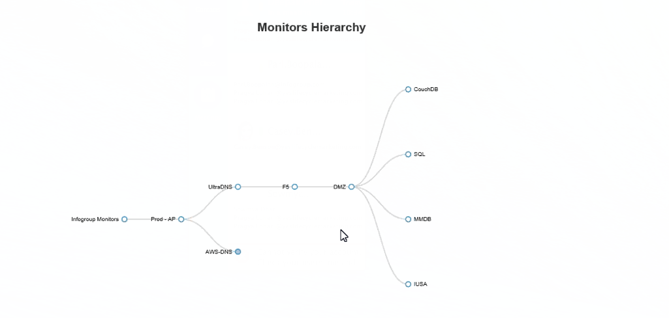

The tree chart will be expandable through different nodes that represent each module. The nodes are displayed in a hierarchical order from web, DMZ, firewall, LB to the individual monitors. Each module’s node can be expanded to view a list of all associated monitors. To reduce the view, nodes are collapsible and will only display the module’s name.

When a module is not working as expected, the “leaf” or visual line leading to that node will be highlighted in orange. When a module is down, the “leaf” or visual line leading to that node will be highlighted in red. The red and orange coloring will travel down the entire “leaf” to guide the user to what specific monitor is down. This will allow the user to easily distinguish when a module is not working as expected or down and the specific monitor that is affected.

**Collapsed Nodes**

User will be able to hover over each node and be displayed the module’s monitor’s status. When a monitor is working as expected, a green arrow pointing up will be displayed. When a monitor is not working as expected or down, an orange or red arrow pointing up will be displayed.

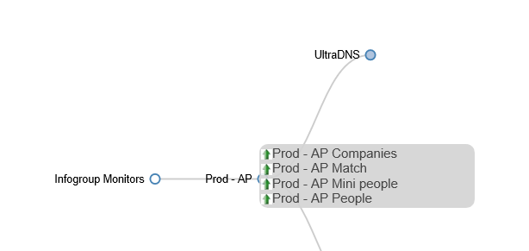

**Expanded Nodes**

Users will be able to expand each node and be displayed the full list of related monitors to that module and it’s current status. Users will be able to select a monitor’s name and be displayed additional statistics regarding up time or down time.

**Statistics**

When a monitors is up:

* Total up time.
* Total call time.
* Clients of this monitor.
* How many calls made by client.

When a monitor is down:

* What is down.
* List of client that are affected
* Total down time.
* Who has been contacted of this outage.

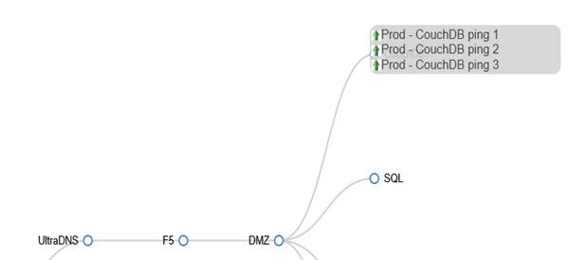

**Analysis**

The Analysis dashboard gives the user a breakdown of Infoconnect’s different modules and their monitors. There will be graphs that break down the total number of monitors by module and total monitors by status. The graphs will provide drill through for the user to view numeric representation of the monitor’s and their status.

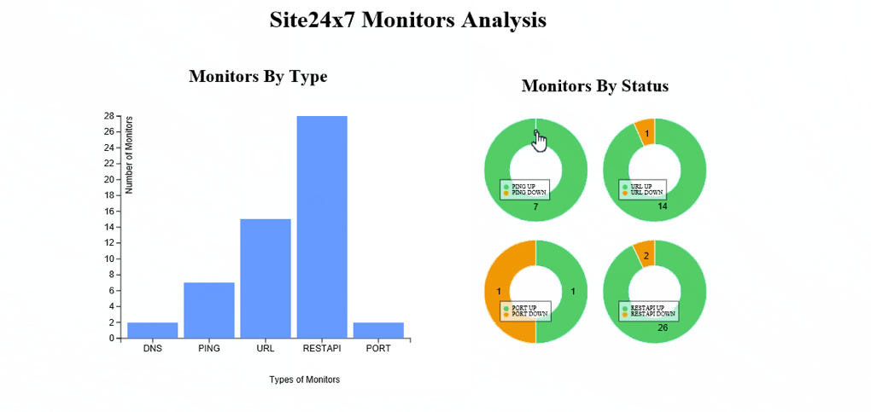

# Summary Reports

Summary reports will be generated for the Infoconnect team. In addition, Site 24X7 provides an interface for users to generate their own summary reports. This interface within Site 24X7 is called “Availability Summary Reports”. Users are able to view a summary report of all monitors or selected monitors by selecting a specified time range.

* Summary reports will be provided on a weekly schedule to the Infoconnect team regarding down time and response time of each module and it’s monitors.
* An interface will be available where users can select a specific date range or module to view in a summary report. Summary reports will be generated according to the selected date range of module and used for internal analytic purposes.

# User Groups and Notifications

When a specific Infoconnect module is down, an email will be sent out to the associated team members of that module. That member must respond to that email acknowledging they have received the outage notification.

Each team member of an Infoconnect module will be provided Site 24X7 login credentials to view the down time statistics of their module.

**Notifications**

* When a module is down, all related team members and contacts will be notified. Only the team members who work with and on that module will receive a notification. This will eliminate an overload of notifications being sent to unrelated team members.
* User groups will be created within Site 24X7 for each Infoconnect module and it’s team members. These groups will have log in credentials that allow them to log onto Site 24X7 and view the status of their assigned module and specific statistics.
* Outage notifications will be sent in the form of:
  + Email: An individual email will be sent to the assigned group notifying them of the outage.
* Contact information for each of Infoconnect’s modules are below. Contact information is also located: <https://infogroup.atlassian.net/wiki/display/IN/Contact+Details>
  + Apigee:
    - [Connect@infoconnect.com](mailto:Connect@infoconnect.com)
      * The Infoconnect on-call support will be responsible for submitting a ticket with Apigee.
        + Log into the support portal http://apigee.com/about/support/portal
        + Create a new ticket
        + Fill in the details and make sure to add your contact info if it is a P1

Site: http://apigee.com/about/support/portal

User: connect@infogroup.com

PW: HCBliJ3UDN7j

* + ULTRA DNS
    - Email notifications will be sent to:
      * [Unixsystems@infogroup.com](mailto:Unixsystems@infogroup.com)
  + AWS DNS
    - Contact names:
      * Rajesh Chakravarthy
      * Subra Aryasomayajula
      * Tom Ke Tao
    - Email notifications will be sent to:
      * [Mini-Admin@infogroup.com](mailto:Mini-Admin@infogroup.com)
      * [Rajesh.Chakravarthy@infogroup.com](mailto:Rajesh.Chakravarthy@infogroup.com)
      * [Subra.Aryasomayajula@infogroup.com](mailto:Subra.Aryasomayajula@infogroup.com)
      * [Tom.Ketao@infogroup.com](mailto:Tom.Ketao@infogroup.com)
        + Mini Admins are responsible for opening a ticket with Amazon.
  + F5
    - Email notifications will be sent to:
      * [NetworkEngineering@infogroup.com](mailto:NetworkEngineering@infogroup.com)
  + Couch DB
    - Contact names:
      * Matthew Rinkenberger
      * Jeff Kulesa
      * Ken Knaub
      * Craig Ferraguti
    - Email notifications will be sent to:
      * [WebAdmin@infogroup.com](mailto:WebAdmin@infogroup.com)
      * [Matthew.Rinkenberger@infogroup.com](mailto:Matthew.Rinkenberger@infogroup.com)
      * [Jeff.Kulesa@infogroup.com](mailto:Jeff.Kulesa@infogroup.com)
      * [Ken.Knaub@infogroup.com](mailto:Ken.Knaub@infogroup.com)
      * [Craig.Ferraguti@infogroup.com](mailto:Craig.Ferraguti@infogroup.com)
  + SQL Server
    - Email notifications will be sent to:
      * [SQLServerDBA@infogroup.com](mailto:SQLServerDBA@infogroup.com)
  + MMDB
    - Contact Names:
      * Anjani Kumar
      * Varad Sampath
    - Email notifications will be sent:
      * [MMDBSupport@infogroup.com](mailto:MMDBSupport@infogroup.com)
      * [MMDBDataAnalysts@infogroup.com](mailto:MMDBDataAnalysts@infogroup.com)
      * [Anjani.Kumar@infogroup.com](mailto:Anjani.Kumar@infogroup.com)
      * [Varadarajan.Sampath@infogroup.com](mailto:Varadarajan.Sampath@infogroup.com)
  + IUSA Match
    - Email notifications will be sent:
      * [Prod.ops@infogroup.com](mailto:Prod.ops@infogroup.com)
  + MINI V1
    - Contact names:
      * Rajesh Chakravarthy
      * Subra Aryasomayajula
      * Tom Ke Tao
    - Emails will be sent to:
      * [Mini-Admin@infogroup.com](mailto:Mini-Admin@infogroup.com)
      * [Rajesh.Chakravarthy@infogroup.com](mailto:Rajesh.Chakravarthy@infogroup.com)
      * [Subra.Aryasomayajula@infogroup.com](mailto:Subra.Aryasomayajula@infogroup.com)
      * [Tom.Ketao@infogroup.com](mailto:Tom.Ketao@infogroup.com)

# Escalation Plan

* Team members for each Infoconnect module are responsible for creating and executing an escalation plan when there is an outage. The resolution of the issue much be completed in a timely manner.
* Infoconnect has an on call 24X7 developer for support that can be reached by a phone (402-297-3840). The Infoconnect module’s team members must notify the Infoconnect on call developer of the outage.
* If a module goes down, team members are responsible for:
  + Resolving the issue.
  + Notifying and involving the Infoconnect on call developer of the issue.
  + If the Infoconnect on call developer is not notified, they will be reaching out for an update on the issue.

**Escalation Process**

1. Issue Identification
   * Module team members must identify what caused the module to go down.
2. Issue Resolution
   * Module team members must identify when and how the issue will be resolved.
     1. If there is no issue resolution, the team must provide a timeline of when the issue resolution will be known.
     2. If there is an issue resolution, the team will provide a timeline of when the issue will be resolved.
3. Update Infoconnect Team
   * Module team members must update the larger Infoconnect team.
     1. Phone Number 402-297-3840
     2. Email [connect@infogroup.com](mailto:connect@infogroup.com)
   * Update Infoconnect team about:
     1. When to expect the next update.
     2. Who the update will be coming form.
4. Root Cause Analysis (RCA)
   * Module team members must reach out to the monitor’s service provider for RCA.
   * Example: AWS DNS Module Team members must reach out to AWS and ask for a root cause analysis and why did that module fail.
   * RCA documentation must to be available if client asks for documentation on issue.

# Infoconnect Monitoring Dashboard: Client Facing

The Infoconnect Monitoring Client Facing Dashboard will be a place for clients to go to in order to see the status of Infoconnect. This page will be solely for the use of the client.

* This page will notify the client of:
  + Infoconnect’s current status.
    - If Infoconnect is up or down.
  + Total number of calls made by client.
  + Type of calls made broken down by Infoconnect’s four API’s:
    - Company API
    - People API
    - Match API
    - SIC API
  + Total number of matches.
* This page must provide a section that will notify clients of scheduled Infoconnect maintenance. Infoconnect will be able to post to this section for specific client interaction.
* No hardcoding is needed. Features and details of this page will be driven by Site 24X7’s API.